COURSERA IBM
DATA SCIENCE CAPSTONE PROJECT:
OPENING A NEW BERMESE RESTAURANT IN TORONTO
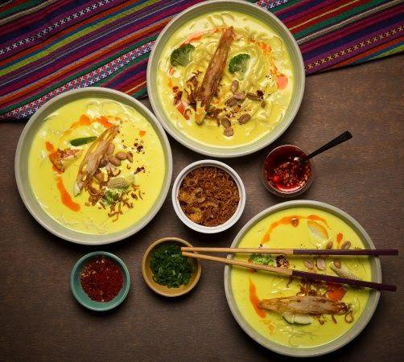

Report Prepared by:

ADITYA CHATURVEDULA
INTRODUCTION:

For this Capstone project, I am creating a hypothetical scenario for a concept Burmese restaurateur who wants to explore opening an authentic Burmese restaurant in Toronto area. The idea behind this project is that there may not be enough Burmese restaurants in Toronto and it might present a great opportunity for this entrepreneur who is based in Canada. As Burmese food is very similar to other Asian cuisines, this entrepreneur is thinking of opening this restaurant in locations where Asian food is popular (aka many Asian restaurants in the neighbourhood). With the purpose in mind, finding the location to open such a restaurant is one of the most important decisions for this entrepreneur and I am designing this project to help him find the most suitable location.

BUSINESS PROBLEM:

The objective of this capstone project is to find the most suitable location for the entrepreneur to open a new Burmese restaurant in Toronto, Canada. By using data science methods and machine learning methods such as clustering, this project aims to provide solutions to ansIr the business question: In Toronto, if an entrepreneur wants to open a Burmese restaurant, where should they consider opening it?

TARGET AUDIENCE:

The entrepreneur who wants to find the location to open authentic Burmese restaurant

DATA:

To solve this problem, I will need below data:

- List of neighbourhoods in Toronto, Canada.

- Latitude and Longitude of these neighbourhoods.

- Venue data related to Asian restaurants. This will help us find the neighbourhoods that are most suitable to open a Burmese restaurant.

EXTRACTING THE DATA:

- Scrapping of Toronto neighbourhoods via Wikipedia

- Getting Latitude and Longitude data of these neighbourhoods via Geocoder package

- Using Foursquare API to get venue data related to these neighbourhoods
METHODOLOGY:

First, I need to get the list of neighbourhoods in Toronto, Canada. This is possible by

extracting the list of neighbourhoods from wikipedia page

(“​https://en.wikipedia.org/wiki/List_of_postal_codes_of_Canada:_M​”)

I did the web scraping by utilizing pandas html table scraping method as it is easier and more convenient to pull tabular data directly from a web page into data frame.

However, it is only a list of neighbourhood names and postal codes. I will need to get their coordinates to utilize Foursquare to pull the list of venues near these neighbourhoods. To get the coordinates, I tried using Geocoder package but it was not working so I used the csv file provided by IBM team to match the coordinates of Toronto neighbourhoods. After gathering all these coordinates, I visualized the map of Toronto using Folium package to verify whether these are correct coordinates.

Next, I use Foursquare API to pull the list of top 100 venues within 500 meters radius. I have created a Foursquare developer account in order to obtain account ID and API key to pull the data. From Foursquare, I am able to pull the names, categories, latitude and longitude of the venues. With this data, I can also check how many unique categories that I can get from these venues. Then, I analyse each neighbourhood by grouping the rows by neighbourhood and taking the mean on the frequency of occurrence of each venue category. This is to prepare clustering to be done later.

Here, I made a justification to specifically look for “Thai restaurants”. Previously, when I ran the model, I was looking for “Asian restaurants” but there are very few results (maybe due to Foursquare categorization) so I looked for the restaurants closest to Burmese cuisine taste (side note: Burmese food and Thai food are very similar in taste, so my justification is that if there are people who enjoyed Thai food, they likely are going to enjoy Burmese food too!) Lastly, I performed the clustering method by using k-means clustering. K-means clustering algorithm identifies k number of centroids, and then allocates every data point to the nearest cluster, while keeping the centroids as small as possible. It is one of the simplest and popular unsupervised machine learning algorithms and it is highly suited for this project as well. I have clustered the neighbourhoods in Toronto into 3 clusters based on their frequency of occurrence for “Thai food”. Based on the results (the concentration of clusters), I will be able to recommend the ideal location to open the restaurant.
RESULTS:

Clusters
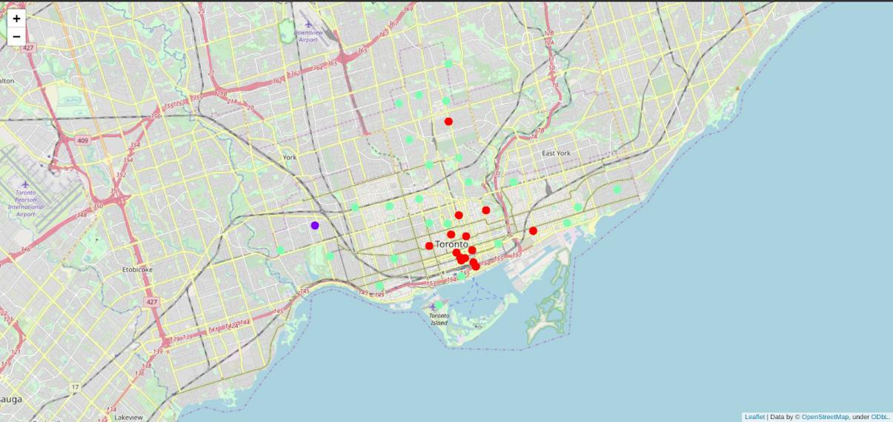

The results from k-means clustering show that we can categorize Toronto neighbourhoods into 3 clusters based on how many Thai restaurants are in each neighbourhood:

- Cluster 0: Neighbourhoods with little or no Thai restaurants

- Cluster 1: Neighbourhoods with no Thai restaurants

- Cluster 2: Neighbourhoods with high number of Thai restaurants

The results are visualized in the above map with Cluster 0 in red colour, Cluster 1 in purple colour and Cluster 2 in light green colour.

RECOMMENDATIONS:

Most of Thai restaurants are in Cluster 2 which is around Adelaide, King, Richmond areas and lowest (close to zero) in Cluster 1 areas which are North Toronto West and Parkdale areas.

Also, there are good opportunities to open near Chinatown, St James town as the competition seems to be low. Looking at nearby venues, it seems Cluster 1 might be a good location as there are not a lot of Asian restaurants in these areas. Therefore, this project recommends the entrepreneur to open an authentic Burmese restaurant in these locations with little to no competition. Nonetheless, if the food is authentic, affordable and good taste, I am confident that it will have great following everywhere :)
LIMITATIONS AND SUGGESTIONS FOR FUTURE RESEARCH:

In this project, I only take into consideration of one factor: the occurrence / existence of Thai restaurants in each neighbourhood. There are many factors that can be taken into consideration such as population density, income of residents, rent that could influence the decision to open a new restaurant. However, to put all these data into this project is not possible to do within a short time frame for this capstone project. Future research can take into consideration of these factors. In addition, I am relying on the existence of Thai restaurants only for this project but future research can take into consideration of other variables such as existence of Asian restaurants, Asian population level in each neighbourhood etc.

CONCLUSION:

In this project, we have gone through the process of identifying the business problem, specifying the data required, extracting and preparing the data, performing the machine learning by utilizing k-means clustering and providing recommendation to the stakeholder.

REFERENCES:

List of neighbourhoods in Toronto:

https://en.wikipedia.org/wiki/List_of_postal_codes_of_Canada:_M

Foursquare Developer Documentation:
​https://developer.foursquare.com/docs

